NAME:NEER AWASTHI

CLASS:A4 B2 20

PRACTICAL 6

Aim: Construction of OBST

Problem Statement: Smart Library Search Optimization

Task 1:

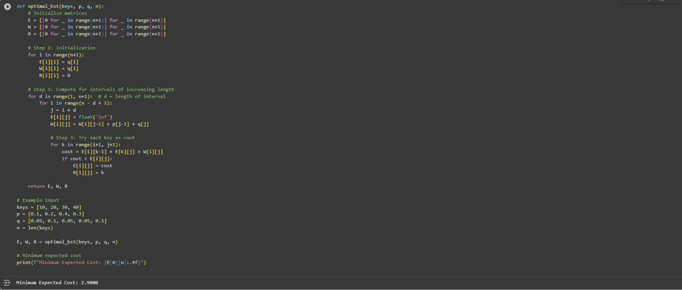

Task 2:

